Functionality: Font Size, Bold, Italic, Underline, Alignment

Code:

text_editor = tk.Text(win)

text_editor.config(wrap='word',relief=tk.FLAT)

text_editor.focus_set()

scroll_bar = tk.Scrollbar(win)

scroll_bar.pack(side=tk.RIGHT,fill=tk.Y)

text_editor.pack(fill=tk.BOTH,expand=True)

scroll_bar.config(command=text_editor.yview)

text_editor.config(yscrollcommand=scroll_bar.set)

#font family and font size functionalities

current_font_family = "Arial"

current_font_size = 12

def change_font(event=None):

selected_text = text_editor.tag_ranges(tk.SEL)

if selected_text:

# Apply font to selected text only

text_editor.tag_add("custom_font", *selected_text)

text_editor.tag_config("custom_font", font=(font_family.get(), current_font_size))

else:

# Set default font for new text entries if nothing is selected

text_editor.configure(font=(font_family.get(), current_font_size))

def change_size(event=None):

selected_text = text_editor.tag_ranges(tk.SEL)

if selected_text:

# Apply font size to selected text only

text_editor.tag_add("custom_size", *selected_text)

text_editor.tag_config("custom_size", font=(current_font_family, size_var.get()))

else:

# Set default font size for new text entries if nothing is selected

text_editor.configure(font=(current_font_family, size_var.get()))

# Bind font and size comboboxes to these functions

font_combo.bind("<<ComboboxSelected>>", change_font)

size_combo.bind("<<ComboboxSelected>>", change_size)

#****************buttons functionality

def change_bold():

try:

current_tags = text_editor.tag_names("sel.first")

if "bold" in current_tags:

text_editor.tag_remove("bold", "sel.first", "sel.last")

else:

text_editor.tag_add("bold", "sel.first", "sel.last")

bold_font = font.Font(text_editor, text_editor.cget("font"))

bold_font.configure(weight="bold")

text_editor.tag_configure("bold", font=bold_font)

except tk.TclError:

pass

bold_button.configure(command=change_bold)

#italic functionality

def change_italic():

try:

current_tags = text_editor.tag_names("sel.first")

if "italic" in current_tags:

text_editor.tag_remove("italic", "sel.first", "sel.last")

else:

text_editor.tag_add("italic", "sel.first", "sel.last")

italic_font = font.Font(text_editor, text_editor.cget("font"))

italic_font.configure(slant="italic")

text_editor.tag_configure("italic", font=italic_font)

except tk.TclError:

pass

italic_button.configure(command=change_italic)

#underline functionality

def change_underline():

try:

current_tags = text_editor.tag_names("sel.first")

if "underline" in current_tags:

text_editor.tag_remove("underline", "sel.first", "sel.last")

else:

text_editor.tag_add("underline", "sel.first", "sel.last")

underline_font = font.Font(text_editor, text_editor.cget("font"))

underline_font.configure(underline=True)

text_editor.tag_configure("underline", font=underline_font)

except tk.TclError:

pass

underline_button.configure(command=change_underline)

#now we will do allignment

def left():

text_content = text_editor.get(1.0,'end')

text_editor.tag_config('left',justify=tk.LEFT)

text_editor.delete(1.0,tk.END)

text_editor.insert(tk.INSERT,text_content,'left')

align_left_button.configure(command=left)

def center():

text_content = text_editor.get(1.0,'end')

text_editor.tag_config('center',justify=tk.CENTER)

text_editor.delete(1.0,tk.END)

text_editor.insert(tk.INSERT,text_content,'center')

align_center_button.configure(command=center)

def right():

text_content = text_editor.get(1.0,'end')

text_editor.tag_config('right', justify=tk.RIGHT)

text_editor.delete(1.0, tk.END)

text_editor.insert(tk.INSERT,text_content, 'right')

align_right_button.configure(command=right)

Explanation:

1. change_font
- Purpose:
To allow users to change the font family of the selected text or the default text for new entries.
- Functionality:
  - If text is selected, the function applies the chosen font family to the selected text.
  - If no text is selected, it updates the default font family for all new text entries.
- How It Works:
  - Uses tag_ranges(tk.SEL) to check if there is selected text.
  - If selected text exists, a tag (custom_font) is created and configured with the new font family.
  - If no text is selected, the configure method of text_editor updates the default font family.

2. change_size
- Purpose:
To allow users to adjust the font size of the selected text or the default text for new entries.
- Functionality:
  - If text is selected, the function applies the chosen font size to the selected text.
  - If no text is selected, it updates the default font size for all new text entries.
- How It Works:
  - Similar to change_font, it checks for selected text using tag_ranges(tk.SEL).
  - If text is selected, a tag (custom_size) is created and configured with the new font size.
  - For new text entries, the configure method updates the default font size.

3. change_bold
- Purpose:
To toggle the bold styling for selected text.
- Functionality:
  - If the selected text is already bold, it removes the bold styling.
  - If the text is not bold, it applies bold styling.

- How It Works:
  - Retrieves the current tags of the selected text using tag_names.
  - If the tag bold exists, it removes the tag; otherwise, it adds the bold tag.
  - Configures a new font.Font object, sets its weight to bold, and applies it to the bold tag using tag_configure.

4. change_italic
- Purpose:
To toggle the italic styling for selected text.
- Functionality:
  - If the selected text is already italicized, it removes the italic styling.
  - If the text is not italicized, it applies italic styling.
- How It Works:
  - Retrieves the current tags of the selected text.
  - If the tag italic exists, it removes the tag; otherwise, it adds the italic tag.
  - Configures a font.Font object with the slant set to italic and applies it to the italic tag.

5. change_underline
- Purpose:
To toggle the underline styling for selected text.
- Functionality:
  - If the selected text is already underlined, it removes the underline styling.
  - If the text is not underlined, it applies underline styling.
- How It Works:
  - Checks the current tags of the selected text.
  - If the underline tag exists, it is removed; otherwise, it is added.
  - Configures a font.Font object with the underline property set to True and applies it to the underline tag.

6. left
- Purpose:
To align all text in the editor to the left.
- Functionality:
  - Retrieves the current text content.
  - Configures a left tag with justify=tk.LEFT.
  - Deletes the existing text and reinserts it with the left tag applied.
- How It Works:
  - Retrieves text using get(1.0, 'end').
  - Configures a new tag (left) to align text to the left.
  - Deletes the current content and re-inserts it with the left tag applied.

7. center
- Purpose:
To align all text in the editor to the center.
- Functionality:
  - Retrieves the current text content.
  - Configures a center tag with justify=tk.CENTER.
  - Deletes the existing text and reinserts it with the center tag applied.
- How It Works:
  - Similar to the left function, but the center tag is configured with justify=tk.CENTER to center-align the text.

8. right
- Purpose:
To align all text in the editor to the right.

- Functionality:
  - Retrieves the current text content.
  - Configures a right tag with justify=tk.RIGHT.
  - Deletes the existing text and reinserts it with the right tag applied.
- How It Works:
  - Similar to left and center functions, but the right tag is configured with justify=tk.RIGHT to right-align the text.

Summary
Each function is designed to provide formatting or alignment capabilities within the text editor. They operate using Tkinter's tagging system, where styles or properties are applied to text ranges through dynamically created tags. This system ensures that formatting is both granular and customizable for the user.

SnapShots:

Font Size, Bold, Italic, Underline:
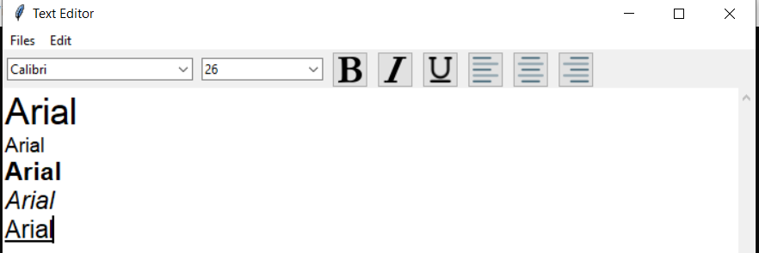

Alignment:

Left:

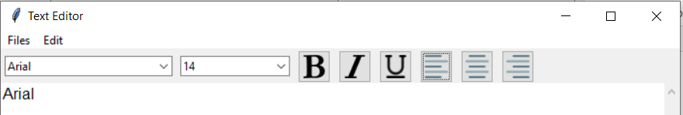

Center:

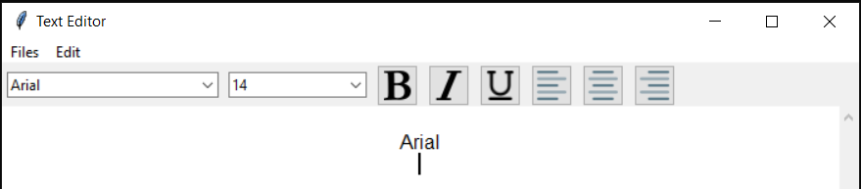

Right:

